**Lab practical 02**

**COA**

**Question:**

**Write a program in assembly language to perform addition of 8-bit data.**

**Code:**

**num1 db 18h**

**num2 db 18h**

**start:**

**mov al,num1;moving num1 to al register**

**add al,num2;moving num2 to al register(i.e, num1 and num2 are in al)**

**mov bl,al ;coping al value to bl,storing for the result dispaly**

**mov ah,al;coping al values to ah,(converting upper nibble 4bit to get character)**

**and ah,0F0h; mask the lower nibble(i.e,converting lower nibble to 0)**

**shr ah,4;shifting right by 4 to get upper nibble**

**add ah,30h;(converting to ascii digit)**

**cmp ah,39h;compare ah value,if it is less than 39h**

**jle print_first_digit**

**add ah,7;convert to ascii**

**print_first_digit:**

**mov dl,ah;coping ah value to dl for printing first digit**

**mov ah,02h;BIOS interrupt to display character**

**int 21h**

**;converting lowwer nibble 4bit to character**

**mov ah,bl;coping bl values to ah**

**and ah,0Fh; mask the upper nibble(i.e,converting upper nibble to 0)**

**add ah,30h;(converting to ascii digit)**

**cmp ah,39h;compare ah value,if it is less than 39h**

**jle print_second_digit**

**add ah,7;convert to ascii**

**print_second_digit:**

**mov dl,ah;coping ah value to dl for printing first digit**

**mov ah,02h;BIOS interrupt to display character**

**;End of the program**

**int 21h**

**mov ah,4Ch**

**int 21h**

**OUTPUT:**

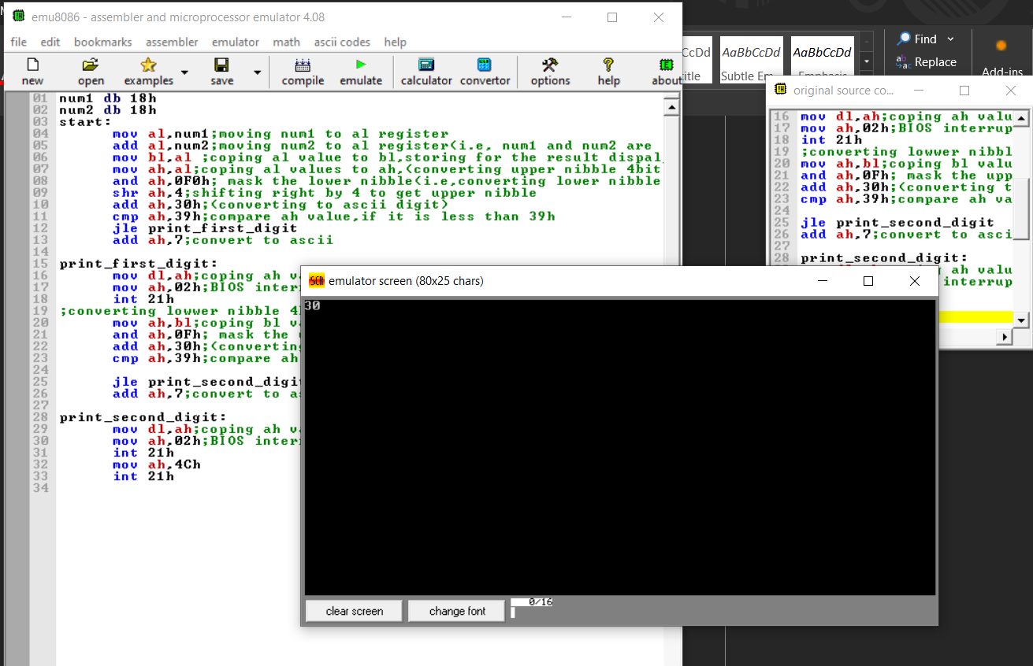

**Question:**

**Write a program in assembly language to perform addition of 16-bit data.**

**CODE:**

**ORG 100h**

**NUM1 DW 1234h ; Define first 16-bit number**

**NUM2 DW 5678h ; Define second 16-bit number**

**START:**

**MOV AX, NUM1 ; Move NUM1 to AX register**

**ADD AX, NUM2 ; Add NUM2 to AX register (AX = NUM1 + NUM2)**

**; Convert result to ASCII and display**

**MOV BX, AX ; Copy result to BX for further processing**

**; Process higher byte of the result**

**MOV AH, BH ; Move higher byte of result to AH**

**SHR AH, 4 ; Shift right by 4 to get upper nibble**

**ADD AH, 30h ; Convert to ASCII**

**CMP AH, 39h ; Compare if less than '9'**

**JLE PRINT_HIGH_NIBBLE**

**ADD AH, 7 ; Convert to ASCII letter if necessary**

**PRINT_HIGH_NIBBLE:**

**MOV DL, AH ; Move AH to DL for printing**

**MOV AH, 02h ; BIOS interrupt to display character**

**INT 21h**

**; Process lower nibble of the higher byte**

**MOV AH, BH ; Move higher byte of result to AH**

**AND AH, 0Fh ; Mask upper nibble**

**ADD AH, 30h ; Convert to ASCII**

**CMP AH, 39h ; Compare if less than '9'**

**JLE PRINT_LOW_NIBBLE**

**ADD AH, 7 ; Convert to ASCII letter if necessary**

**PRINT_LOW_NIBBLE:**

**MOV DL, AH ; Move AH to DL for printing**

**MOV AH, 02h ; BIOS interrupt to display character**

**INT 21h**

**; Process upper nibble of the lower byte**

**MOV AH, BL ; Move lower byte of result to AH**

**SHR AH, 4 ; Shift right by 4 to get upper nibble**

**ADD AH, 30h ; Convert to ASCII**

**CMP AH, 39h ; Compare if less than '9'**

**JLE PRINT_HIGH_NIBBLE2**

**ADD AH, 7 ; Convert to ASCII letter if necessary**

**PRINT_HIGH_NIBBLE2:**

**MOV DL, AH ; Move AH to DL for printing**

**MOV AH, 02h ; BIOS interrupt to display character**

**INT 21h**

**; Process lower nibble of the lower byte**

**MOV AH, BL ; Move lower byte of result to AH**

**AND AH, 0Fh ; Mask upper nibble**

**ADD AH, 30h ; Convert to ASCII**

**CMP AH, 39h ; Compare if less than '9'**

**JLE PRINT_LOW_NIBBLE2**

**ADD AH, 7 ; Convert to ASCII letter if necessary**

**PRINT_LOW_NIBBLE2:**

**MOV DL, AH ; Move AH to DL for printing**

**MOV AH, 02h ; BIOS interrupt to display character**

**INT 21h**

**MOV AH, 4Ch ; Terminate program**

**INT 21h**

**OUTPUT:**

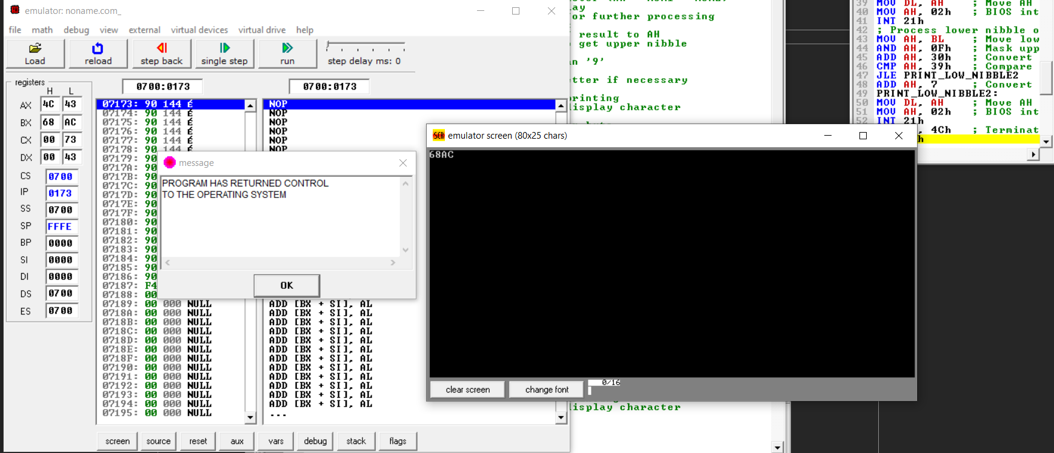

**GITHUB:**